Entity framework

Adding to console application

Step 1: Create a new console application and do the following steps:

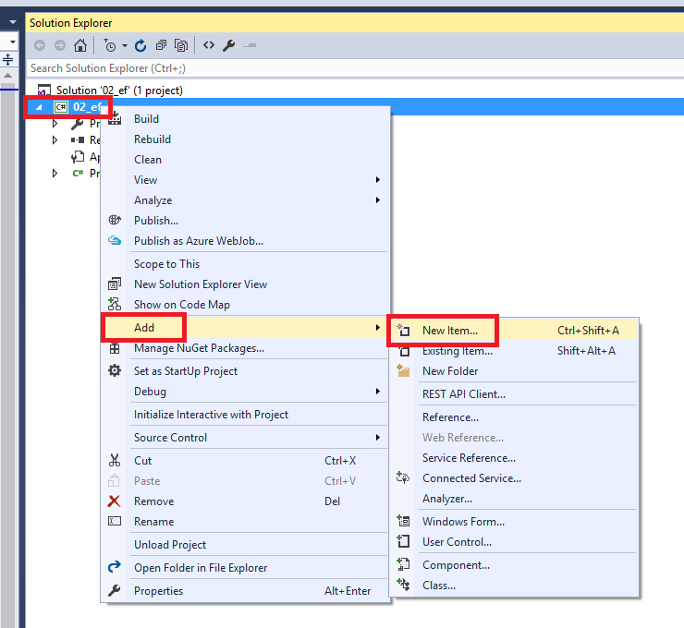

Step 2

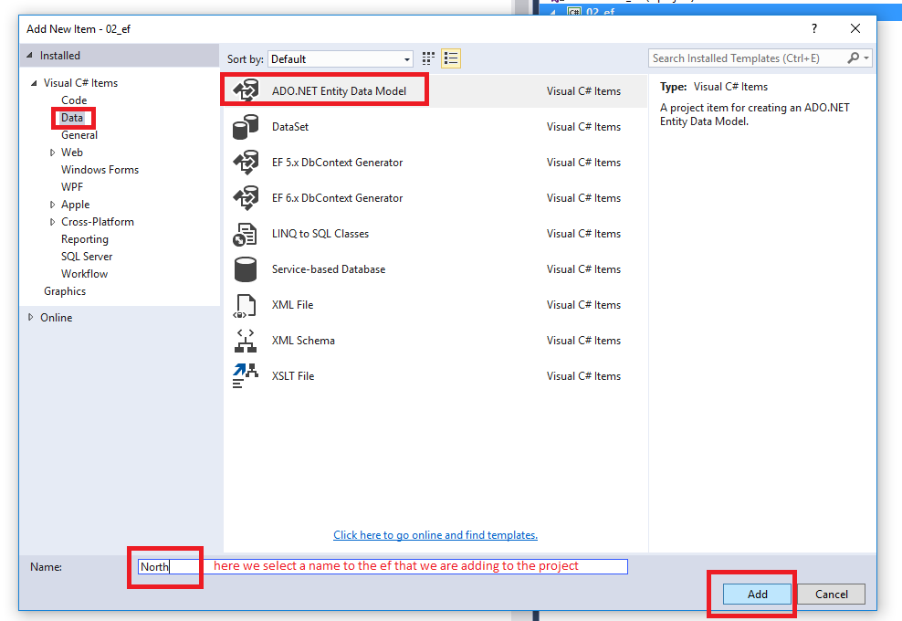

Step 3

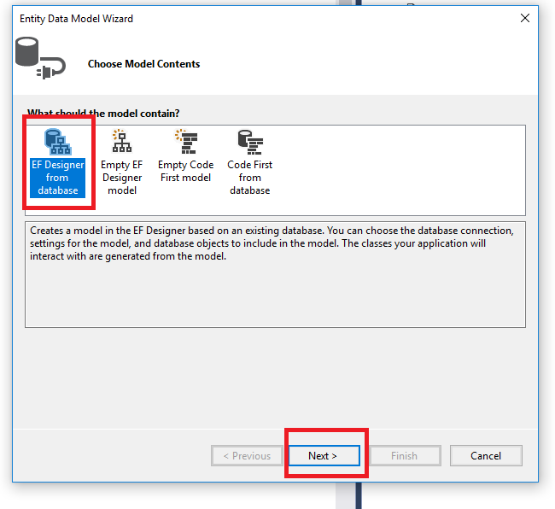

Step 4

Create the connection string to the DB

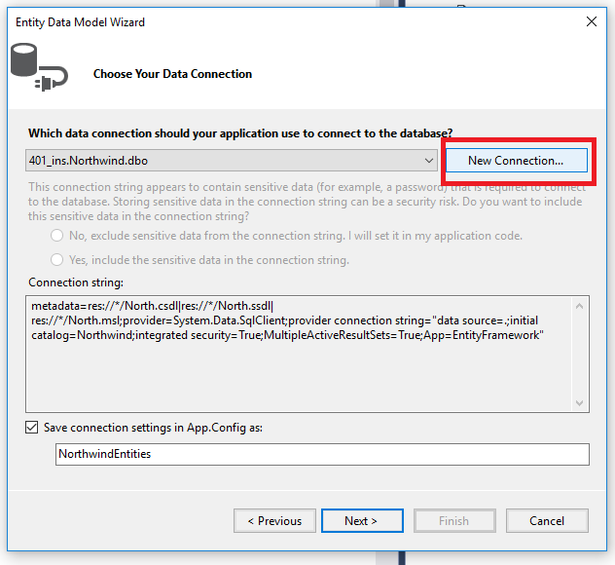

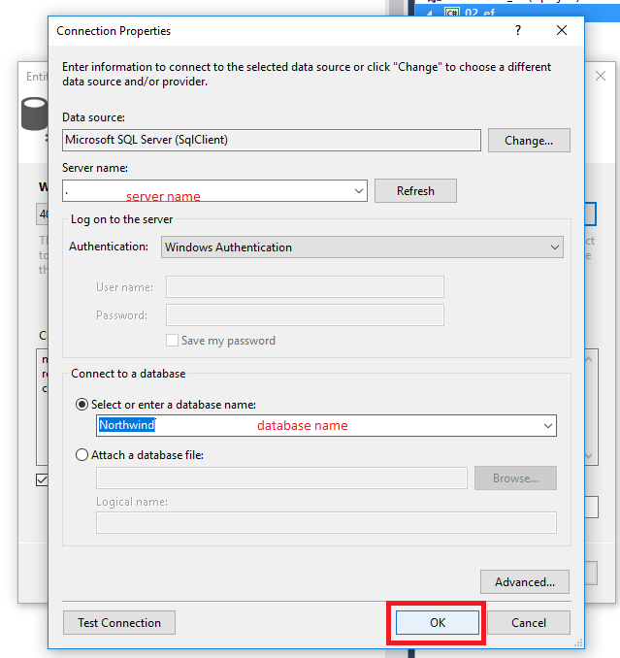

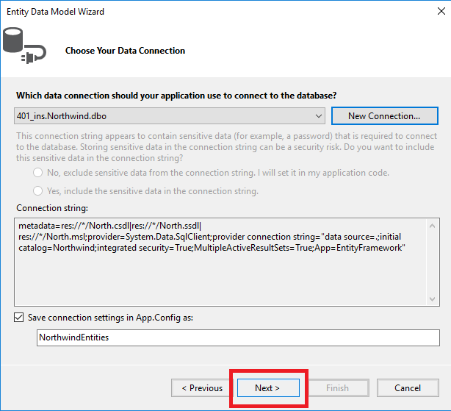

Step 5: select ef version

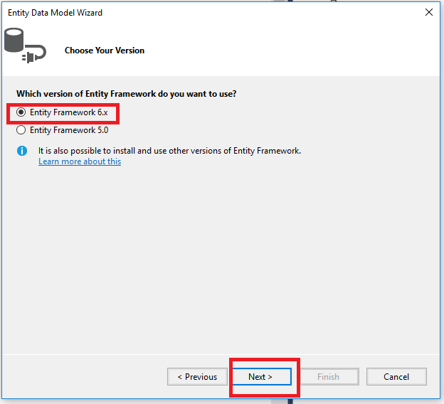

Step 6:

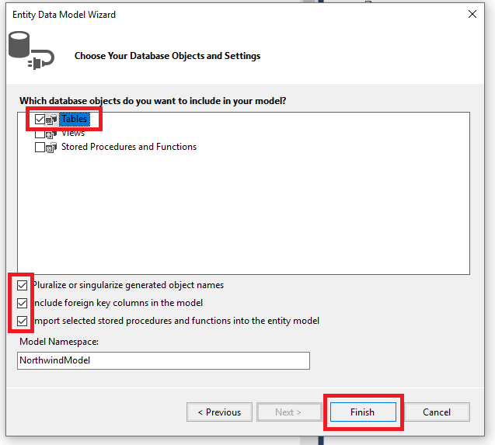

Entity framework

Added files by EF

After adding the ef to the console application, as we explained above, we get the connection string and ef config in the “app.config” file:

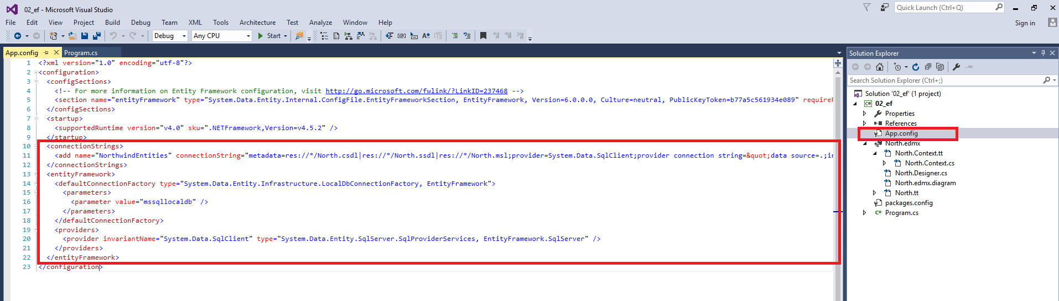

In addition, we get all the following content:

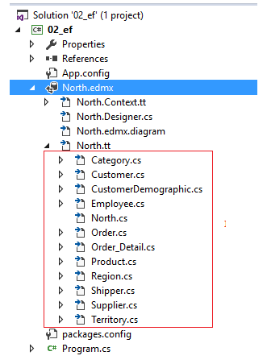

Bellow, we will explain each part of this files:

**Class Model for each table in the DB**

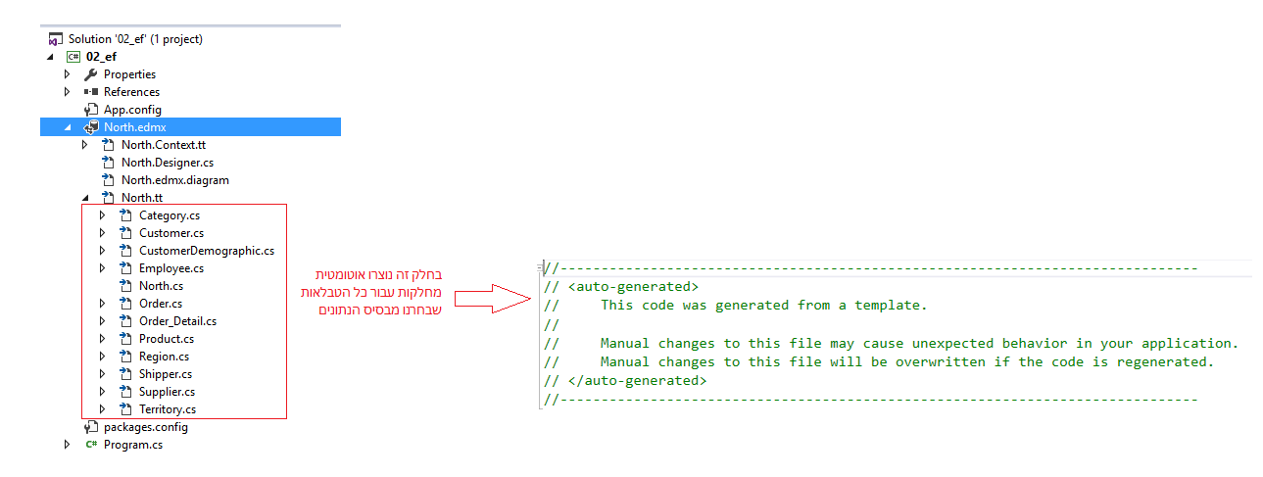

**Diagram content**

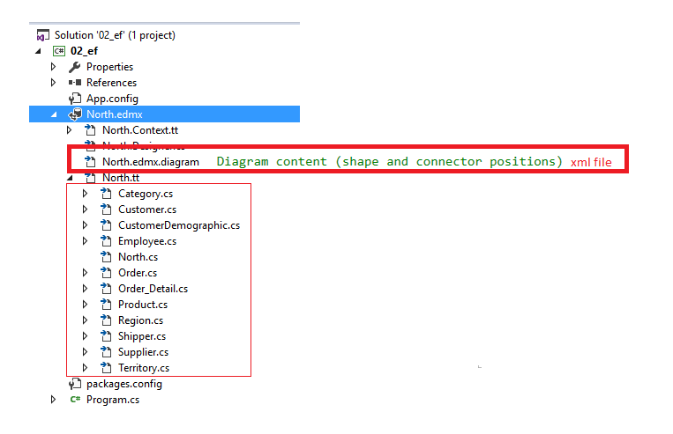

**Class that represents the DB with all the tables (DbSet for each table):**

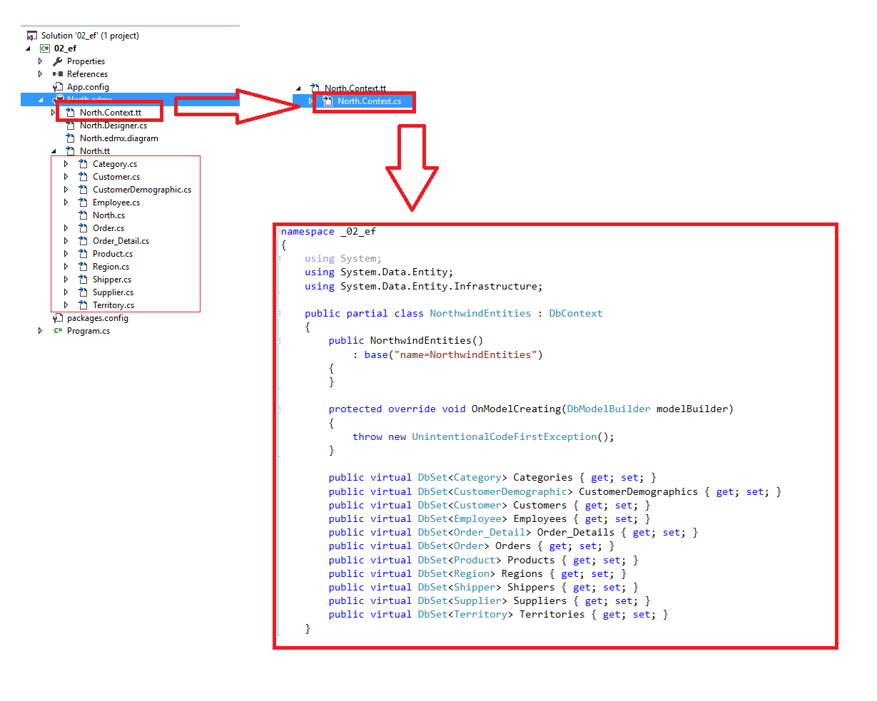

**DB diagram**

